Athlete Questionnaire
Name:
DOB:
Occupation:
Contact number:
Health conditions:
Physio/doctor best contact:
Where did you hear about us?
Insert link to your Strava
And/or Garmin account.
Address: (for your Evolve merch)
Size & preference –
singlet or t-shirt?

Goal ambitions or races for the year
Fill what is relevant to you.
A races are your biggest goals, B races are one’s you’d like to do well in, C races are training races (ie Park run)
 | Distance | Where | When | Why
A races

B races

C races

Other goal

- Which of those races have you done before?

- If you have how did you go in them?

- Where did you do well and where do you think you can improve.

Training
Give me a brief run down on your most recent training regime.
Usual training week;
Days in a normal week
Distance per week and on your average runs
Time of day etc
Speeds per km (easy running)
Terrain – hills, bitumen
Long run

Lets talk speed work;
Where do you do most of your runs?
What do your intervals look like?
Time taken to complete these intervals?
Most weekly mileage you have been able to sustain. Due to fatigue, body, or other considerations?

Training with other people groups
1. If you would like to do some of your sessions with other people/ groups - which ones, what day(s) of the week and what kind of session(s) are they?

Terrain available to train on
1. What kind of climbs do you have access to? ie trail/ road, steep / gradual, long/ short how long would it take to run up - technical/ fire trail

2. Do you have a surface for speed work? Oval, running track or any flat measurable surface to do speed work on

Body
Any previous major running injuries | Any current niggles | Any areas of weakness that you have to watch | Other medical condition that affects your training

Mental
Strengths | Weaknesses

Available time
1. What days do you prefer to train?

2. How much time do you have available to train on those days?

Previous Race history
- Please list PB's and any major results so I can get an understanding of what speeds you have run.
1km | 5km | 10km | HM | M | Trail

- If you could also list your current form that would also be great.

- What is your racing experience like?

Additional Training
Please detail any other physical activity you do - eg gym, cycling, swimming, yoga, sports.

Shoes
What shoes do you run in and how happy are you with them?

Training Recording
What GPS recording do you use? Please let us know which one so we can connect with you and track your training.

Please also connect with Evolve Run Club on Facebook, Garmin Connect or Strava.
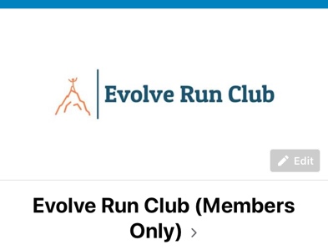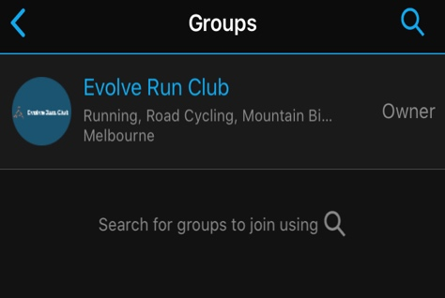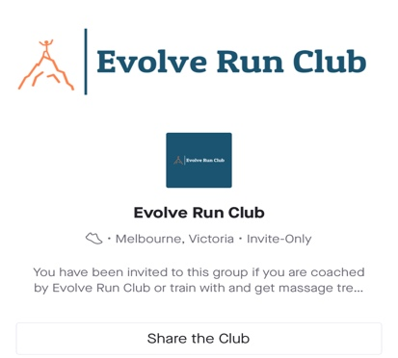

Regarding the training program.
You will receive a program for you every 4-5 weeks. Each program will be delivered to you before the start of the next block. You can cease our arrangement after the completion of your current plan, of course. I would like to keep a transparent relationship with communication also. So, if you have any feedback please speak up and I will best accommodate your requests.

Please note, by signing up to a program, you acknowledge you are in good health and able to undertake an exercise regime. You agree to wave Dion Finocchiaro & Evolve Run Club coaches from accountability of injuries sustained from the prescribed exercises and training plans.

Cost: $80 per month for basic or $120 per month for premium coaching.
Triathlon coaching and group sessions including a plan are premium by default.
There is also a once off set-up fee of $30 which can be paid into the Evolve Run Club account.
Minimum 3-month commitment.

Basic
Premium

BSB – 083 004
Account number - 748922099
Reference – Your name
Payment can be made on week 1 of training block, each month. Direct debit is encouraged.
You will receive a recurring monthly invoice via Xero, delayed payments may result in a delay of your training program.

